EXPERIMENT – 2

EXP No: 2

Date: ___________

Title
DDL Commands with Constraints – PRIMARY KEY, FOREIGN KEY, UNIQUE, CHECK

AIM
To implement PRIMARY KEY, FOREIGN KEY, UNIQUE and CHECK constraints in the Drone Delivery Management System.

DESCRIPTION
Constraints are used to maintain data integrity and enforce valid data in the database.

PROCEDURE
- Open MySQL Command Line.
- Select the DroneDelivery database.
- Apply PRIMARY KEY constraints.
- Apply UNIQUE constraints.
- Apply CHECK constraints.
- Apply FOREIGN KEY constraints.
- Verify the tables.
Query 1
USE DroneDelivery;
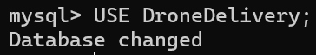

Query 2
ALTER TABLE Customers
ADD CONSTRAINT PK_Customers
PRIMARY KEY (CustomerID);
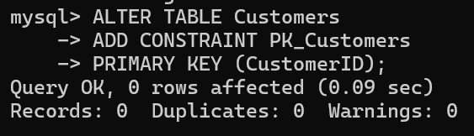
Query 3
ALTER TABLE Drones
ADD CONSTRAINT PK_Drones
PRIMARY KEY (DroneID);
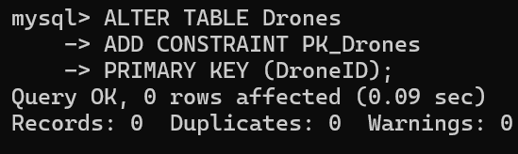
Query 4
ALTER TABLE Deliveries
ADD CONSTRAINT PK_Deliveries
PRIMARY KEY (DeliveryID);
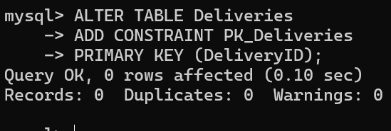

Query 5
ALTER TABLE Customers
ADD CONSTRAINT UK_Customers_Phone
UNIQUE (Phone);
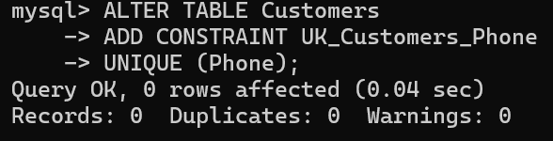
Query 6
ALTER TABLE Drones
ADD CONSTRAINT CHK_Payload
CHECK (PayloadCapacity > 0);
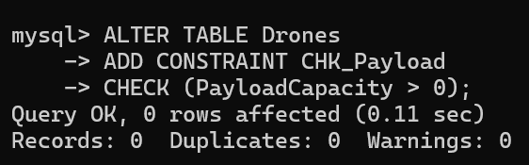
Query 7
ALTER TABLE Drones
ADD CONSTRAINT CHK_DroneStatus
CHECK (DroneStatus IN ('Available','Busy','Maintenance'));
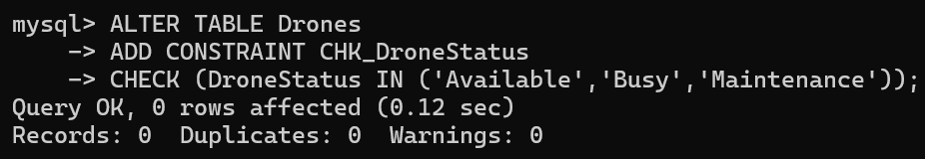

Query 8
ALTER TABLE Deliveries
ADD CONSTRAINT FK_Customer
FOREIGN KEY (CustomerID)
REFERENCES Customers(CustomerID);
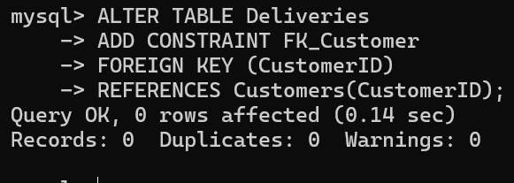
Query 9
ALTER TABLE Deliveries
ADD CONSTRAINT FK_Drone
FOREIGN KEY (DroneID)
REFERENCES Drones(DroneID);
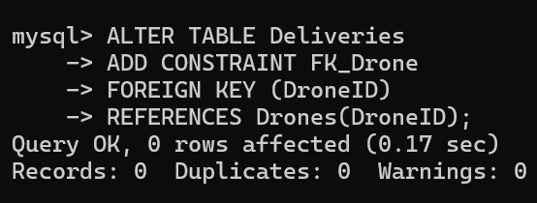
Query 10
SHOW CREATE TABLE Customers\G
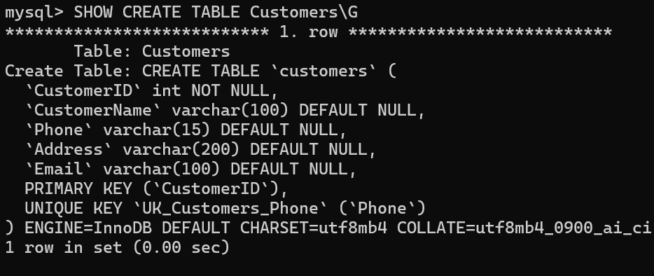

SHOW CREATE TABLE Drones\G
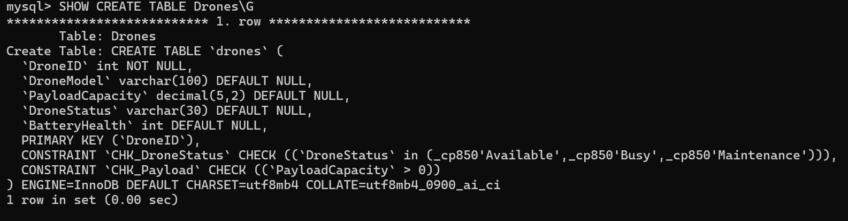

SHOW CREATE TABLE Deliveries\G
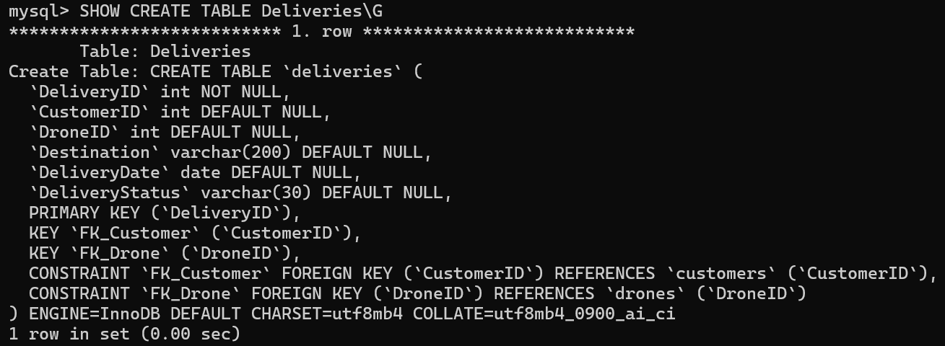

RESULT
Thus, PRIMARY KEY, FOREIGN KEY, UNIQUE, and CHECK constraints were successfully implemented in the Drone Delivery Management System.

